**CS4004 Software Testing and Inspection Autumn 2021 Project Specification**

**Due*:** Monday **29** November (9 am Irish time) Marks for this project: **20%** of the module

**Aims:** The lab component of CS4004 covers a variety of tools and some of which are more challenging than others. It also involves some learning which is best done at your own pace. This assignment has two aims:

1**. To guide** you through the learning objectives of the lab sessions

2. **To assess your learning** – to what extent you have achieved these objectives. The assignment is divided into 2 part (group project and individual project) it provide the opportunity for your to can work together and write the contribution of each team member in the Logfile of this project and is deliberately open-ended so you have the opportunity to learn as much as you want and provide the evidence.

**Student Name: Jai.**

**UL Student number:** 20045247

**Assignment:** Final project

**Date of Submission: 29/11/2021**



# STUDENT PLAGIARISM DISCLAIMER FORM

## PLAGIARISM DISCLAIMER

STUDENT NAME: Jai . ____________________________________________________________________

STUDENT NUMBER: 20045247 __________________________________________________________________

PROGRAMME: (LM051) Bachelor of Computer Systems ______________________________________________________________________

YEAR: 2 _____________________________________________________________________________

MODULE: (CS4004) Software Testing and Inspection __________________________________________________________________________

LECTURER: Dr. Salim Saay _________________________________________________________________________

Individual Project TITLE: Billing _____________________________________________________________

DUE DATE: 29/11/2021_________________________________________________________________________

DATE SUBMITTED: 29/11/2021___________________________________________________________________

ADDITIONAL INFORMATION: ___________________________________________________________

I understand that plagiarism is a serious academic offence, and that UL deals with it according to the UL Policy on Plagiarism.

I have read and understand the UL Policy on Plagiarism and I agree to the requirements set out therein in relation to project and referencing. I confirm that I have referenced and acknowledged properly all sources used in preparation of this project. I understand that if I plagiarise, or if I assist others in doing so, that I will be subject to investigation as outlined in the UL Policy on Plagiarism.

I understand and agree that plagiarism detection software may be used on my project. I declare that, except where appropriately referenced, this project is entirely my own work based on my personal study/or research. I further declare that I have not engaged the services of another to either assist in, or complete this project.

## Signed: JAI

**Dated: 29/11/2021**

**Group Project Title: RESTURANT MANGEMENT**

1. Description of project: In this project, I along with my group members took on this project, titled, ‘Restaurant Management System’ that deals with the management aspects of the different departments and respective components within a restaurant management system. I took on the department of Food and Kitchen Inventory, that dealt with the dealings and functioning of ongoing things within that department. Similarly, my fellow group members also took up other departments within the restaurant management as their individual topics. My fellow teammate Jai took up the department of Billing management and system. My fellow teammate, Konan, took up the department of Supplier Management and lastly my fellow teammate Thomas, took up the department of Customer Relation and management. We all worked together while simultaneously working on our individual part of the projects to emulate this management system of our Restaurant.
2. Team members:

* Rohan Arya (20086377)
* Jai (20045247)
* Konan Heney (20242603)
* Thomas Finnan (20183143)

1. **Task 1 Teamwork report**

**Supplier Management:**

My fellow teammate, Konan, took up the department of Supplier Management where whatever items within the restaurant are supplied and demanded, its management is taken care by this system.

**Customer Relation and management:**

My fellow teammate Thomas took up the department of Customer Relation and management, that deals with services offered to customer liking waiting tables, coordination of orders, feedback and inputs.

**Food and Kitchen Inventory**

Here, my teammate Rohan take care of the management of the Food and Kitchen inventory. He manages all the products required to make all the dishes available on the menu and ensure all the items that are required as the ingredients for the different recipes of the dishes available on the menu, are always in supply.

**Individual Project Title: Billing**

1. Description of project:

After noticing the rise in small businesses and entrepreneurs, especially in restaurants we decide to take up the task of developing a dime application to generate bills for a restaurant.   
The application generates a unique Bill Number for each new bill produced, which helps keep a record of transactions better.   
The application is a simple system and is easy to use making it more convenient to promote and implement.

Personally, I found dime not useful at all as I do not see any logic behind this software. Also, the software crashes 9/10 times and takes forever to deploy on the web , which makes it extremely difficult and time consuming to do this project

1. Category of Requirements (User story): for example, functional requirements, non-functional requirements, general requirements … (2)

1. List of Requirements under each category…. (2)

1. Prototype of project
   1. Data Model (2)

Example:

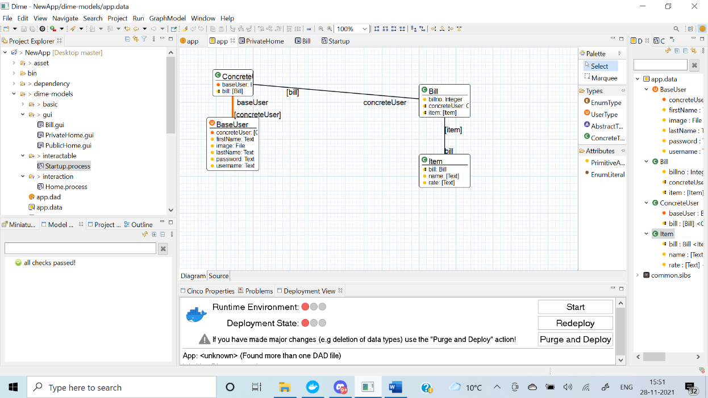

* 1. Process Models (3)

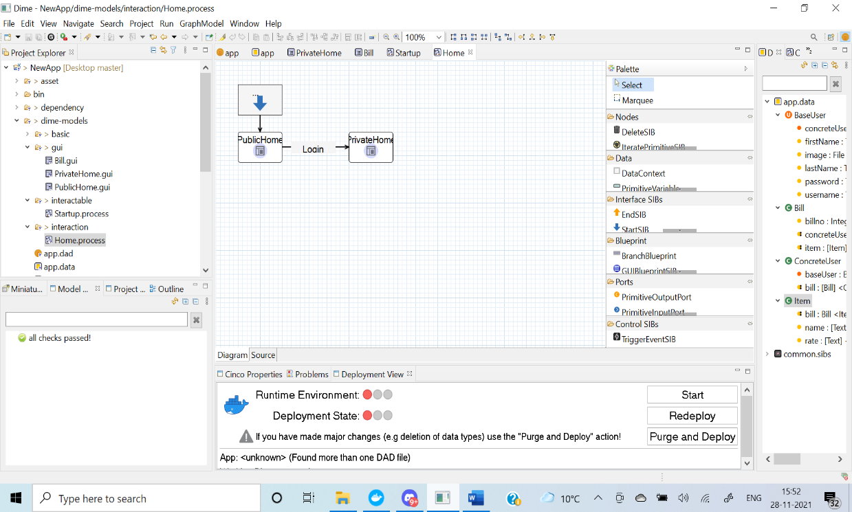

* 1. Interface Models (3)

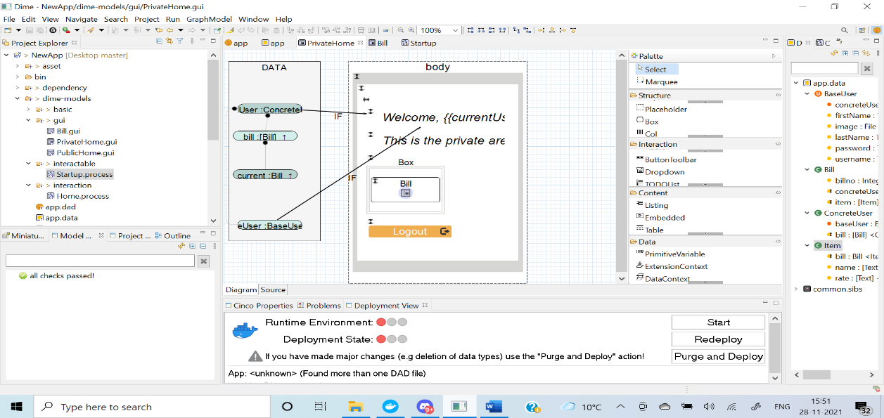

* 1. Interfaces (2)

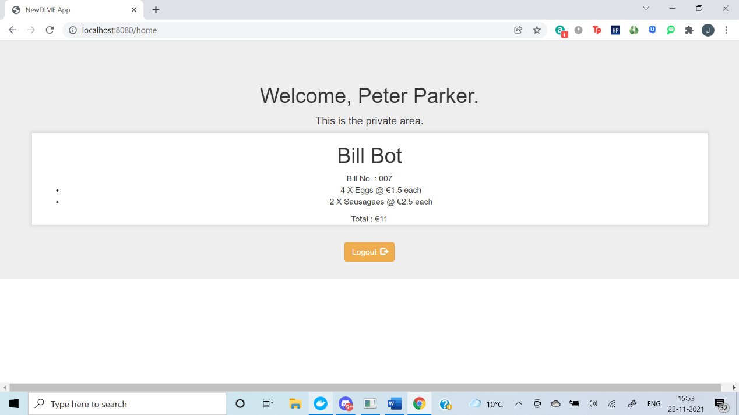

Note: The source of the project also needs to be uploaded in a zip folder to SULIS.

**Example in windows**: Open the DIME folder>>Workspace>> right click on the project folder>> send to Zip

